This is the original design document. The actual design was altered during implementation. For up to date documentation, see the HTML Help file.

Object Model for WBFL COGO

Overview
The WBFL COGO package provides an engineer with the ability to represent simple highway alignments in a program. This package is not intended to be a roadway design engine or a bridge geometry engine. With this package, you can create an XY Cartesian coordinate system, model geometric objects such as lines, points, and arc, compute the locations of points, and represent a roadway alignment along with its associated profile and cross sections. Using the alignment, profile, and section, you can location points at known stations, compute elevations, and cross slopes.

CogoModel
This is the top-level coordinate geometry model. This object manages all of the components of a coordinate geometry model included points, lines, curves, alignments, and profiles.
Implements
 | ICogoModel | Primary interface for the Cogo Model object
 | ILocate | Interface used for locating points
 | IProject | Interface used for locating points by projecting them onto lines, curves, and alignments
 | IIntersect | Interface used for locating points by intersecting lines and curves
 | IMeasure | Interface used to measure angles, distances, and areas
 | IDivide | Interface used to create points by dividing distances, lines, and curves

ICogoModel
Primary interface of a COGO Model object
Properties
 | Points | Returns a collection of Point2d objects along the horizontal alignment
 | LineSegments | Returns a collection of LineSegment2d objects
 | HorzCurves | Returns a collection of HorzCurve objects
 | Alignments | Returns a collection of Alignment objects
 | ProfilePoints | Returns a collection of ProfilePoint objects
 | VertCurves | Returns a collection of VertCurve objects
Methods
 | Clear | Clears all elements from the cogo model
Events
 | OnChanged | Fired when something in the cogo model changes

Properties

Points
Summary: | Returns a collection of Point objects
Syntax: | pntColl = object.Points
Syntax: | Element | Description
Syntax: | pntColl | reference to the collection
Syntax: | object | this CogoModel object
Remarks:
Also See:

Lines
Summary: | Returns a collection of Line objects
Syntax: | lnColl = object.Lines
Syntax: | Element | Description
Syntax: | lnColl | reference to the collection
Syntax: | object | this CogoModel object
Remarks:
Also See:

HorzCurves
Summary: | Returns a collection of HorzCurve objects
Syntax: | crvColl = object.HorzCurves
Syntax: | Element | Description
Syntax: | crvColl | reference to the collection
Syntax: | object | this CogoModel object
Remarks:
Also See:

Alignments
Summary: | Returns a collection of Alignment objects
Syntax: | aliColl = object.Alignments
Syntax: | Element | Description
Syntax: | aliColl | reference to the collection
Syntax: | object | this CogoModel object
Remarks:
Also See:

ProfilePoints
Summary: | Returns a collection of ProfilePoint objects
Syntax: | pntColl = object.ProfilePoints
Syntax: | Element | Description
Syntax: | pntColl | reference to the collection
Syntax: | object | this CogoModel object
Remarks:
Also See:

VertCurves
Summary: | Returns a collection of VertCurve objects
Syntax: | crvColl = object.VertCurves
Syntax: | Element | Description
Syntax: | crvColl | reference to the collection
Syntax: | object | this CogoModel object
Remarks:
Also See:

Methods

Clear
Summary: | Clears all elements from the Cogo Model
Syntax: | object.Clear
Syntax: | Element | Description
Syntax: | object | this CogoModel object
Remarks: | Also reinitializes all model defaults
Also See:

Events

OnChanged
Summary: | Fires when something in the COGO model changes
Syntax: | obect.OnChanged
Syntax: | Element | Description
Syntax: | object | this CogoModel object
Remarks:
Also See:

ILocate
This interface is used to locate points and lines in the Cogo Model.
Methods
 | ByDistAngle | Locates a point by distance and angle
 | ByDistDefAngle | Locates a point by distance and deflection angle
 | ByDistDir | Locates a point by distance and direction
 | ParallelLine | Locates a line parallel to a specified line
 | ParallelLineByPoinst | Locates a line parallel to two points
 | PointOnLine | Locates a point on a line

Methods

ByDistAngle
Summary: | Locates a point by distance and angle
Syntax: | object.Locate.ByDistAngle(newID,fromID,toID,dist,varAngle,offset)
Syntax: | Element | Description
Syntax: | object.Locate | Locate interface of this Cogo Model
Syntax: | newID | Id of the new point
Syntax: | fromID | Starting point of the reference line
Syntax: | toID | Ending point of the reference line
Syntax: | dist | Distance from the reference line at which to locate the point
Syntax: | varAngle | Angle at which to locate the point
Syntax: | offset | Offset normal to the reference line
Remarks: | 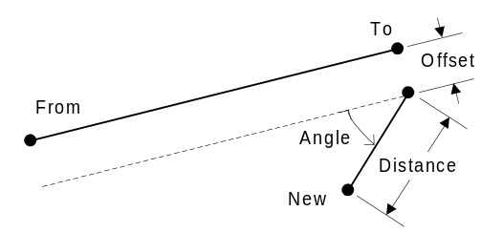  varAngle can be an Angle object, or an angle in radians  Positive offsets are to the right of the line when viewed from the From point to the To point.
Also See:

ByDistDefAngle
Summary: | Locates a point by distance and deflection angle
Syntax: | object.Locate.ByDistDefAngle(newID,fromID,toID,dist,varAngle,offset)
Syntax: | Element | Description
Syntax: | object.Locate | Locate interface of this Cogo Model
Syntax: | newID | Id of the new point
Syntax: | fromID | Starting point of the reference line
Syntax: | toID | Ending point of the reference line
Syntax: | dist | Distance from the reference line at which to locate the point
Syntax: | varAngle | Angle at which to locate the point
Syntax: | offset | Offset normal to the reference line
Remarks: | 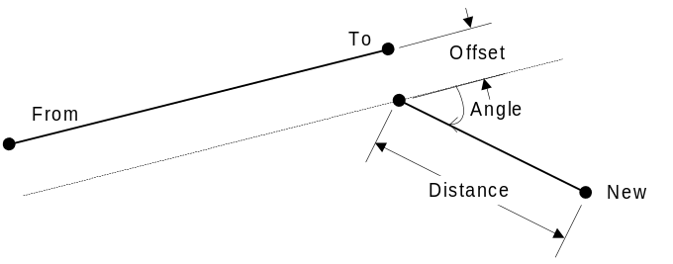  varAngle can be an Angle object, or an angle in radians. A negative deflection angle is shown above.  Positive offsets are to the right of the line when viewed from the From point to the To point.
Also See:

ByDistDir
Summary: | Locates a point by distance and direction
Syntax: | object.Locate.ByDistDir(newID,fromID,toID,dist,dir,offset)
Syntax: | Element | Description
Syntax: | object.Locate | Locate interface of this Cogo Model
Syntax: | newID | Id of the new point
Syntax: | fromID | Starting point of the reference line
Syntax: | toID | Ending point of the reference line
Syntax: | dist | Distance from the reference line at which to locate the point
Syntax: | dir | Direction object
Syntax: | offset | Offset normal to the reference line
Remarks: | 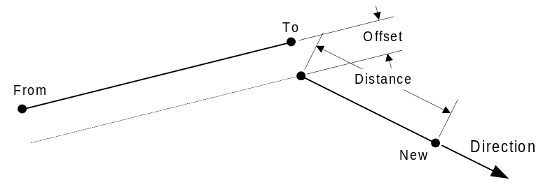  Positive offsets are to the right of the line.
Also See:

ParallelLine
Summary: | Locates a line parallel to a specified line
Syntax: | object.Locate.ParallelLine(newID,lineID,offset)
Syntax: | Element | Description
Syntax: | object.Locate | Locate interface of this Cogo Model
Syntax: | newID | Id of the new line
Syntax: | lineID | Id of the reference line
Syntax: | offset | Offset normal to the reference line
Remarks: | 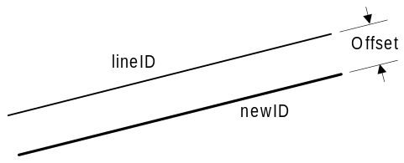  Positive offsets are to the right of the line.
Also See:

ParallelLineByPoints
Summary: | Locates a line parallel to two points
Syntax: | object.Locate.ParallelLineByPoints(newID,fromID,toID,offset)
Syntax: | Element | Description
Syntax: | object.Locate | Locate interface of this Cogo Model
Syntax: | newID | Id of the new line
Syntax: | fromID | Starting point of the reference line
Syntax: | toID | Ending point of the reference line
Syntax: | offset | Offset normal to the reference line
Remarks: | 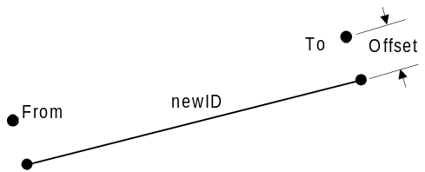  Positive offsets are to the right of the line.
Also See:

PointOnLine
Summary: | Locates a point on a line
Syntax: | object.Locate.PointOnLine(newID,fromID,toID,dist,offset)
Syntax: | Element | Description
Syntax: | object.Locate | Locate interface of this Cogo Model
Syntax: | newID | Id of the new line
Syntax: | fromID | Starting point of the reference line
Syntax: | toID | Ending point of the reference line
Syntax: | dist | Distance from the start of the line to the new point
Syntax: | offset | Offset normal to the reference line
Remarks: | 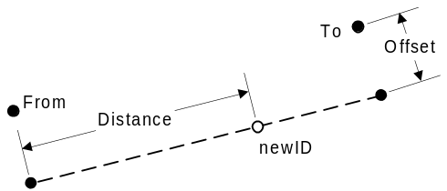  Negative distances will locate the point before the From point  Positive offsets are to the right of the line.
Also See:

IProject
This interface is used to locate points in the Cogo Model by using projection.
Methods
 | PointOnLine | Locates a point by projecting a point onto a line
 | BetweenPoints | Locates a point by projecting a point onto a line formed by two previously defined points

Methods

PointOnLine
Summary: | Locates a point by projecting a point onto a line at an angle normal to the line.
Syntax: | object.Project.PointOnLine(newID,fromID,lineID,offset)
Syntax: | Element | Description
Syntax: | object.Project | Project interface of this Cogo Model
Syntax: | newID | ID of the newly created point
Syntax: | fromID | ID of the point that will be projected onto the line
Syntax: | lineID | ID of the reference line that the point will be projected onto
Syntax: | offset | Offset from the reference line to the actual projection line
Remarks: | 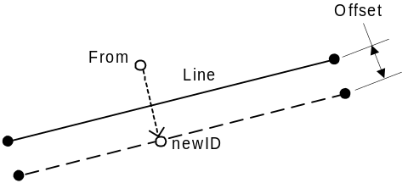  Positive offsets are to the right of the line.
Also See:

BetweenPoints
Summary: | Locates a point by projecting a point onto a line formed by two previously defined points
Syntax: | object.Project.BetweenPoints(newID,fromID,startID,endID,offset)
Syntax: | Element | Description
Syntax: | object.Project | Project interface of this Cogo Model
Syntax: | newID | ID of the new point
Syntax: | fromID | ID of the point to be projected
Syntax: | startID | ID of the starting point
Syntax: | endID | ID of the ending point
Syntax: | offset | Offset normal to the line formed by the start and end points to the line onto which the point is projected
Remarks: | 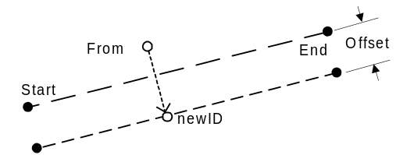  Positive offsets are to the right of the line.
Also See:

IIntersect
Interface used for locating points by intersecting lines and curves
Methods
 | BearingBearing | Finds the intersection of two lines defined by bearings
 | BearingCircle | Finds the intersection of a line and a circle
 | CircleCircle | Finds the intersection of two circles
 | LineLine | Finds the intersection of two lines
 | LineByPointsCircle | Finds the intersection of a line defined by points and a circle
 | LinesByPoints | Finds the intersection of two lines defined by points

Methods

BearingBearing
Summary: | Finds the intersection of two lines defined by bearings
Syntax: | bFound = object.Intersect.BearingBearing(newID,ID1,dir1,ID2,dir2,offset1,offset2)
Syntax: | Element | Description
Syntax: | bFound | Boolean value indicating if an intersection was found
Syntax: | object.Intersect | Intersect interface of this Cogo Model
Syntax: | newID | ID of the intersection point
Syntax: | ID1 | ID of the reference point for the first line
Syntax: | dir1 | Bearing of first line
Syntax: | ID2 | ID of the reference point fo the second line
Syntax: | dir2 | Bearing of the second line
Syntax: | offset1 | Offset normal to the first line
Syntax: | offset2 | Offset normal to the second line
Remarks: | 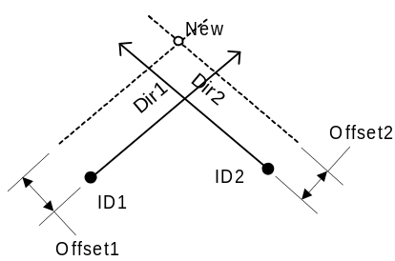  Positive offsets are to the right of the line.
Also See:

BearingCircle
Summary: | Finds the intersection of a line and a circle
Syntax: | bFound = object.Intersect.BearingCircle(newID,ID1,dir,offset,ID2,r,ID3)
Syntax: | Element | Description
Syntax: | bFound | Boolean value indicating if an intersection was found
Syntax: | object.Intersect | Intersect interface of this Cogo Model
Syntax: | newID | ID of the newly created point
Syntax: | ID1 | ID of a point on the reference line
Syntax: | dir | Direction of the reference line
Syntax: | offset | Offset normal to the reference line
Syntax: | ID2 | Center of the circle
Syntax: | r | Radius of the circle
Syntax: | ID3 | A point nearest the intersection point.
Remarks: | There are potentially two intersection points. The point that will be added to the cogo model is the one that is nearest the point identified by ID3.  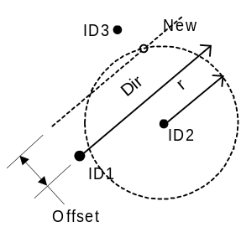  Positive offsets are to the right of the line.
Also See:

CircleCircle
Summary: | Finds the intersection of two circles
Syntax: | bFound = object.Intersect.CircleCircle(newID,ID1,r1,ID2,r2,ID3)
Syntax: | Element | Description
Syntax: | bFound | Boolean value indicating if an intersection was found
Syntax: | object.Intersect | Intersect interface of this Cogo Model
Syntax: | newID | ID of newly created point
Syntax: | ID1 | Center of first circle
Syntax: | r1 | Radius of first circle
Syntax: | ID2 | Center of second circle
Syntax: | r2 | Radius of second circle
Syntax: | ID3 | A point nearest the intersection point.
Remarks: | There are potentially two intersection points. The point that will be added to the cogo model is the one that is nearest the point identified by ID3.  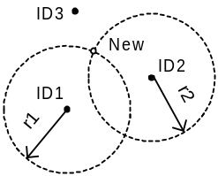
Also See:

LineLine
Summary: | Finds the intersection of two lines
Syntax: | bFound = object.Intersect.LineLine(newID,ID1,ID2,offset1,offset2)
Syntax: | Element | Description
Syntax: | bFound | Boolean value indicating if an intersection was found
Syntax: | object.Intersect | Intersect interface of this Cogo Model
Syntax: | newID | ID of newly created point
Syntax: | ID1 | ID of the first line
Syntax: | ID2 | ID of the second line
Syntax: | offset1 | Normal offset from the first line
Syntax: | offset2 | Normal offset from the second line
Remarks: | 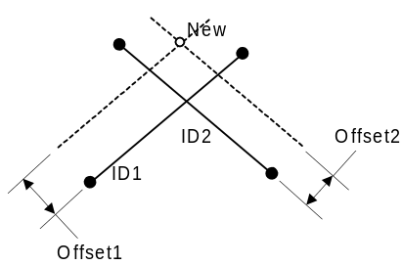  Positive offsets are to the right of the line.
Also See:

LineByPointsCircle
Summary: | Finds the intersection of a line defined by two points and a circle
Syntax: | bFound = object.Intersect.LineByPointsCircle(newID,ID1,ID2,offset,ID3,r,ID4)
Syntax: | Element | Description
Syntax: | bFound | Boolean value indicating if an intersection was found
Syntax: | object.Intersect | Intersect interface of this Cogo Model
Syntax: | newID | ID of newly created point
Syntax: | ID1 | ID of the start of the reference line
Syntax: | ID2 | ID of the end of the reference line
Syntax: | offset | Normal offset from the reference line
Syntax: | ID3 | ID of a point at the center of the circle
Syntax: | r | Radius of the circle
Syntax: | ID4 | A point nearest the intersection
Remarks: | There are potentially two intersection points. The point that will be added to the cogo model is the one that is nearest the point identified by ID4.  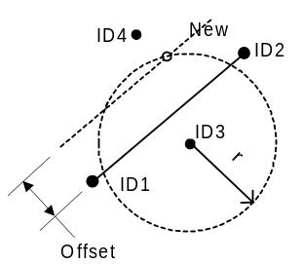  Positive offsets are to the right of the line.
Also See:

LinesByPoints
Summary: | Finds the intersection of two lines defined by points
Syntax: | bFound = object.Intersect.LinesByPointse(newID,ID1,ID2,ID3,ID4,offset1,offset2)
Syntax: | Element | Description
Syntax: | bFound | Boolean value indicating if an intersection was found
Syntax: | object.Intersect | Intersect interface of this Cogo Model
Syntax: | newID | ID of newly created point
Syntax: | ID1 | ID of the start of the first line
Syntax: | ID2 | ID of the end of the first line
Syntax: | ID3 | ID of the start of the second line
Syntax: | ID4 | ID of the end of the second line
Syntax: | offset1 | Normal offset from the first line
Syntax: | offset2 | Normal offset from the second line
Remarks: | 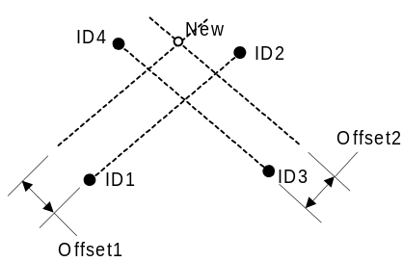  Positive offsets are to the right of the line.
Also See:

IMeasure
Interface used to measure angles, distances, and areas
Methods
 | Angle | Measures the angle formed by three non-coincident points
 | Area | Measures the area of a polygon
 | Distance | Measures the distance between two points
 | Direction | Determines the direction between two points

Methods

Angle
Summary: | Measures the angle formed by three non-coincident points
Syntax: | objAngle = object.Measure.Angle(fromID,vertexID,toID)
Syntax: | Element | Description
Syntax: | objAngle | A new Angle object
Syntax: | object.Measure | Measure interface of this Cogo Model
Syntax: | fromID | Point from which the angle is measured from
Syntax: | vertexID | Point that forms the vertex of the angle
Syntax: | toID | Point to which the angle is measured
Remarks: | 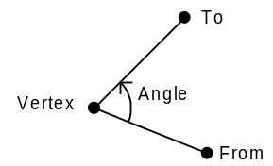  The counter-clockwise angle is computed.
Also See:

Area
Summary: | Measures the area of a polygon
Syntax: | dblArea = object.Measure.Area(id[])
Syntax: | Element | Description
Syntax: | dblArea | The area enclosed by the polygon
Syntax: | object.Measure | Measure interface for this Cogo Model
Syntax: | id[] | A Safe Array of point identifiers
Remarks: | The area of points must contain at least three unique identifiers. It does not matter if the points are defined clockwise or counter-clockwise. The last point need not be the same as the first. Degenerate polygons (polygon with intersecting edges such as a bow-tie shape) are not detected. An incorrect area will be computed if a degenerate polygon is input. Use caution.  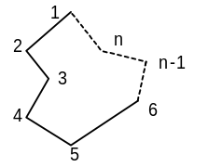
Also See:

Distance
Summary: | Measures the distance between two points
Syntax: | dblDist = object.Measure.Distance(ID1,ID2)
Syntax: | Element | Description
Syntax: | dblDist | Distance between two points
Syntax: | object.Measure | Measure interface on this Cogo Model
Syntax: | ID1 | ID of the first point
Syntax: | ID2 | ID of the second point
Remarks: | 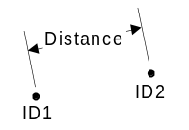
Also See:

Direction
Summary: | Determines the direction between two points
Syntax: | objDir = object.Measure.Direction(ID1,ID2)
Syntax: | Element | Description
Syntax: | objDir | Direction of a line going from the first point to the second point
Syntax: | object.Measure | Measure interface on this Cogo Model
Syntax: | ID1 | ID of the first point
Syntax: | ID2 | ID of the second point
Remarks: | 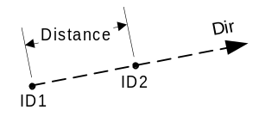
Also See:

IDivide
Interface used to create points by dividing distances, lines, and curves
Methods
 | Arc | Divides an arc
 | HorzCurve | Divides a previously stored horizontal curve
 | Line | Divides a line
 | LineSegment | Divides a previously stored line segment

Methods

Arc
Summary: | Divides an arc
Syntax: | nPoints = object.Divide.Arc(firstID,idInc,fromID,vertexID,toID,nParts)
Syntax: | Element | Description
Syntax: | nPoints | Number of points generated
Syntax: | object.Divide | Divide interface on this Cogo Model
Syntax: | firstID | ID of the first point to be created
Syntax: | idInc | New point ID increment
Syntax: | fromID | Point from which the arc is measured from
Syntax: | vertexID | The vertex point
Syntax: | toID | Point to which the arc is measured
Syntax: | nParts | Number of part into which the arc is divided
Remarks: | This method will divide an arc into nParts equally spaced points. nParts -2 points will be created. There will be nParts + 1 points needed to form the arc. The two end points are specified as inputs and are not duplicated. Points will not be generated if points with the same ID already exist in the model.  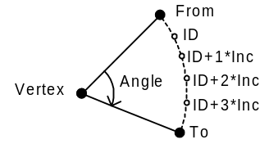
Also See:

HorzCurve
Summary: | Divides a previously stored horizontal curve
Syntax: | nPoints = object.Divide.HorzCurve(firstID,idInc,curveID,nParts)
Syntax: | Element | Description
Syntax: | nPoints | Number of points generated
Syntax: | object.Divide | Divide interface on this Cogo Model
Syntax: | firstID | ID of the first point to be created
Syntax: | idInc | New point ID increment
Syntax: | curveID | ID of the horizontal curve
Syntax: | nParts | Number of part into which the arc is divided
Remarks: | This method will divide a horizontal curve into nParts equally spaced points. nParts -2 points will be created. There will be nParts + 1 points needed to form the arc. The two end points are specified as inputs and are not duplicated. Points will not be generated if points with the same ID already exist in the model.
Also See:

Line
Summary: | Divides a line
Syntax: | nPoints = object.Divide.Line(firstID,idInc,ID1,ID2,nParts)
Syntax: | Element | Description
Syntax: | nPoints | Number of points generated
Syntax: | object.Divide | Divide interface on this Cogo Model
Syntax: | firstID | ID of the first point
Syntax: | idInc | New point ID increment
Syntax: | ID1 | ID of the first point
Syntax: | ID2 | ID of the second point
Remarks: | This method will divide a line into nParts equally spaced points. nParts-2 points will be created. There will be nParts + 1 points needed to from the line. The two end points are specified as inputs and duplicate points are not created. Points will not be generated if points with the same ID already exist in the model.  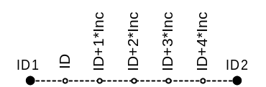
Also See:

LineSegment
Summary: | Divides a previously stored line segment
Syntax: | nPoints = object.Divide.LineSegment(firstID,idInc,segID,nParts)
Syntax: | Element | Description
Syntax: | nPoints | Number of points generated
Syntax: | object.Divide | Divide interface on this Cogo Model
Syntax: | firstID | ID of the first point
Syntax: | idInc | New point ID increment
Syntax: | segID | ID of the line segment
Remarks: | This method will divide a line into nParts equally spaced points. nParts-2 points will be created. There will be nParts + 1 points needed to from the line. The end points of the line segment are not duplicated. Points will not be generated if points with the same ID already exist in the model.
Also See:

IAngle
Interface implemented by Angle objects. Angle objects represent an angle. Positive angles are measured counter-clockwise.
Properties
 | Value | The numerical value of the angle (in radians)
 | Degree | Number of degrees (DMS format)
 | Minute | Number of minutes (DMS format)
 | Second | Number of seconds (DMS format)
Methods
 | Normalize | Normalizes the angle such that its value is between 0 and 2π
 | FromDMS | Sets the value using degrees-minutes-seconds
 | FromString | Sets the value from a formatted string
Events

Properties

Value
Summary: | The numerical value of the angle (in radians)
Syntax: | dblVal = object.Value  object.Value = dblVal
Syntax: | Element | Description
Syntax: | dblVal | The value of the angle
Syntax: | object | This Angle object
Remarks: | This is the default property
Also See:

Degree
Summary: | Number of degrees (DMS format)
Syntax: | sDegree = object.Degree
Syntax: | Element | Description
Syntax: | sDegree | Number of degrees (short)
Syntax: | object | This Angle object
Remarks:
Also See:

Minute
Summary: | Number of minutes (DMS format)
Syntax: | usMin = object.Minute
Syntax: | Element | Description
Syntax: | usMin | Number of minutes (unsigned short)
Syntax: | object | This Angle object
Remarks:
Also See:

Second
Summary: | Number of seconds (DMS format)
Syntax: | dblSec = object.Second
Syntax: | Element | Description
Syntax: | dblSec | Number of seconds
Syntax: | object | This Angle object
Remarks:
Also See:

Methods

Normalize
Summary: | Normalizes the angle such that its value is between 0 and 2π
Syntax: | object.Normalize
Syntax: | Element | Description
Syntax: | object | This Angle object
Remarks:
Also See:

FromDMS
Summary: | Sets the value using degrees-minutes-seconds
Syntax: | object.FromDMS(sDeg,usMin,dblSec)
Syntax: | Element | Description
Syntax: | object | This Angle object
Syntax: | sDeg | Number of degrees (short)
Syntax: | usMin | Number of minutes (unsigned short)
Syntax: | dblSec | Number of seconds
Remarks:
Also See:

FromString
Summary: | Sets the value from a formatted string
Syntax: | object.FromString(strAngle)
Syntax: | Element | Description
Syntax: | object | This Angle object
Syntax: | strAngle | String representation of an angle
Remarks: | Valid string formats  {[+|-]}ddd.ddd Decimal degrees  ddd.ddd {[L|R]} Decimal degrees with optional Left or Right  ddd mm ss.s {[L|R]} Degree-minutes-seconds left or right  {[+|-]}ddd mm ss.s Degree-minutes-seconds
Also See:

Events

Event1
Summary:
Syntax:
Syntax: | Element | Description
Remarks:
Also See:

CogoPoint
The CogoPoint object implements the IPoint2d interface from the WBFL Geometry library. The difference between CogoPoint and Point2d is that CogoPoint fires events when the object is altered.

IDirection
Interface implemented by Direction objects. A Direction object represents a direction in the coordinate space, such as N 35° 14' 23.5" E, or an Azimuth.

The properties of this object represent the direction as a counter-clockwise angle measured from due East and as the constituent parts of a bearing designation as you might find on a survey.
Properties
 | Value | Decimal value representing this direction (radians)
 | North | Indicates the general north/south direction
 | Degree | Number of degrees (DMS)
 | Minute | Number of minutes (DMS)
 | Second | Number of seconds (DMS)
 | East | Indicates the general east/west direction
Methods
 | Increment | Increments the direction by adding an angle to it
 | Decrement | Decrements the direction by subtracting an angle from it
 | FromString | Sets the value using a string
 | FromDMS | Sets the value using Degree-Minutes-Seconds values
 | FromAzimuth | Sets the value using an azimuth
Events

Properties

Value
Summary: | Decimal value representing this direction
Syntax: | dblVal = object.Value  object.Value = dblVal
Syntax: | Element | Description
Syntax: | dblVal | Decimal value representing this direction in radians
Syntax: | object | This Direction object
Remarks: | Due East is 0.0. This value increases with counter-clockwise angles.
Also See:

North
Summary: | Indicates the general north/south direction
Syntax: | dir = object.North
Syntax: | Element | Description
Syntax: | dir | The north/south direction
Syntax: | object | This Direction object
Remarks: | This property indicates the general north/south direction by returning nsNorth or nsSouth. nsNorth indicates the bearing is generally in a northerly direction as in N 45 E.
Also See:

Degree
Summary: | Number of degrees (DMS)
Syntax: | sDeg = object.Degree
Syntax: | Element | Description
Syntax: | sDeg | Number of degrees
Syntax: | object | This Direction object
Remarks:
Also See:

Minute
Summary: | Number of minutes (DMS)
Syntax: | sMin = object.Minute
Syntax: | Element | Description
Syntax: | sMin | Number of minutes
Syntax: | object | This Direction object
Remarks:
Also See:

Second
Summary: | Number of seconds (DMS)
Syntax: | dblSec = object.Second
Syntax: | Element | Description
Syntax: | dblSec | Number of seconds
Syntax: | object | This Direction object
Remarks:
Also See:

East
Summary: | Indicates the general east/west direction
Syntax: | dir = object.East
Syntax: | Element | Description
Syntax: | dir | East/West direction
Syntax: | object | This Direction object
Remarks: | This property indicates the general east/west direction by returning ewEast or ewWest. ewEast indicates the bearing is generally in a easterly direction as in N 45 E.
Also See:

Methods

Increment
Summary: | Increments the direction by adding an angle to it
Syntax: | object.Increment(varAngle)
Syntax: | Element | Description
Syntax: | object | This Direction object
Syntax: | varAngle | An Angle object or floating point number representing the amount to increment this direction
Remarks:
Also See:

Decrement
Summary: | Decrements the direction by subtracting an angle from it
Syntax: | object.Decrement(varAngle)
Syntax: | Element | Description
Syntax: | object | This Direction object
Syntax: | varjAngle | An Angle object or floating point number representing the amount to decrement this direction
Remarks:
Also See:

FromString
Summary: | Set the value using a string
Syntax: | object.FromString(strDir)
Syntax: | Element | Description
Syntax: | object | This Direction object
Syntax: | strDir | Formatted string representing a direction
Remarks: | The format the the string is:  [N|S] dd {mm {ss.s}} [E|W]
Also See:

FromDMS
Summary: | Sets the value using Degree-Minutes-Seconds values
Syntax: | object.FromDMS(nsDir,deg,min,sec,ewDir)
Syntax: | Element | Description
Syntax: | object | This Direction object
Syntax: | nsDir | North/South direction
Syntax: | deg | Number of degrees
Syntax: | min | Number of minutes
Syntax: | sec | Number of seconds
Syntax: | ewDir | East/West direction
Remarks:
Also See:

FromAzimuth
Summary: | Sets the value using an azimuth
Syntax: | object.FromAzimuth(deg,min,sec)
Syntax: | Element | Description
Syntax: | object | Thid Direction object
Syntax: | deg | Number of degrees
Syntax: | min | Number of minutes
Syntax: | sec | Number of seconds
Remarks: | An azimuth of a line is the clockwise angle that the line makes with the north end of the reference meridian.
Also See:

Events

Event1
Summary:
Syntax:
Syntax: | Element | Description
Remarks:
Also See:

I<Type>Collection
Interface implemented by a <Type>Collection object. This is a generic definition. The specific containers are PointContainer, LineSegmentContainer, HorzCurveContainer, AlignmentContainer, ProfilePointContainer, and VertCurveContainer. Containers support in-order traversal (iteration) using custom enumerator objects. The For-Each construct is also supported. For-Each iterates through the keys.

Properties
 | Item | Sets/Gets a <type> object associated with an item in the container
 | Count | Returns the number of items in the container
Methods
 | Add | Adds a new <type> object to the container
 | Remove | Removes a <type> object from the container
Events

Properties

Item
Summary: | Sets/Gets a <type> object associated with an item in the container
Syntax: | objType = object.Item(lKey)  object.Item(lKey) = objType
Syntax: | Element | Description
Syntax: | objType | A <type> object
Syntax: | object | This collection
Syntax: | lKey | A lookup key for the point (its identifier)
Remarks: | Key is unique for every object in a given container type.
Also See:

Count
Summary: | Returns the number of items in the container
Syntax: | lCnt = object.Count
Syntax: | Element | Description
Syntax: | lCnt | The number of items in the container
Syntax: | object | This collection
Remarks:
Also See:

Methods

Add
Summary: | Adds a <type> object to the collection
Syntax: | object.Add(lKey,objType)
Syntax: | Element | Description
Syntax: | object | This collection
Syntax: | lKey | A lookup key for the point (its identifier)
Syntax: | objType | The <type> object to be added
Remarks:
Also See:

Remove
Summary: | Removes a <type> object from the container
Syntax: | object.Remove(lKey)
Syntax: | Element | Description
Syntax: | object | This collection
Syntax: | lKey | A lookup key for the point (its identifier)
Remarks:
Also See:

Events

Event1
Summary:
Syntax:
Syntax: | Element | Description
Remarks:
Also See:

IEnumKeys
Iterator used to enumerate the keys of an I<Type>Collection
Properties
Methods
 | Next | Retrieves a specified number of items in the enumeration sequence
 | Skip | Skips over a specified number of items in the enumeration sequence
 | Reset | Resets the enumeration sequence to the beginning
 | Clone | Creates another enumerator that contains the same enumeration state as the current one.
Events

Properties

Prop1
Summary:
Syntax:
Syntax: | Element | Description
Remarks:
Also See:

Methods

Next
Summary:
Syntax:
Syntax: | Element | Description
Remarks:
Also See:

Skip
Summary:
Syntax:
Syntax: | Element | Description
Remarks:
Also See:

Reset
Summary:
Syntax:
Syntax: | Element | Description
Remarks:
Also See:

Clone
Summary:
Syntax:
Syntax: | Element | Description
Remarks:
Also See:

Events

Event1
Summary:
Syntax:
Syntax: | Element | Description
Remarks:
Also See:

IEnum<Type>
Iterator used to enumerate the <Type> objects in an I<Type>Collection
Properties
Methods
 | Next | Retrieves a specified number of items in the enumeration sequence
 | Skip | Skips over a specified number of items in the enumeration sequence
 | Reset | Resets the enumeration sequence to the beginning
 | Clone | Creates another enumerator that contains the same enumeration state as the current one.
Events

Properties

Prop1
Summary:
Syntax:
Syntax: | Element | Description
Remarks:
Also See:

Methods

Next
Summary:
Syntax:
Syntax: | Element | Description
Remarks:
Also See:

Skip
Summary:
Syntax:
Syntax: | Element | Description
Remarks:
Also See:

Reset
Summary:
Syntax:
Syntax: | Element | Description
Remarks:
Also See:

Clone
Summary:
Syntax:
Syntax: | Element | Description
Remarks:
Also See:

Events

Event1
Summary:
Syntax:
Syntax: | Element | Description
Remarks:
Also See:

IHorizCurve
Interface for describing a horizontal curve. A horizontal curve may contain entry and/or exit clothoid spirals.
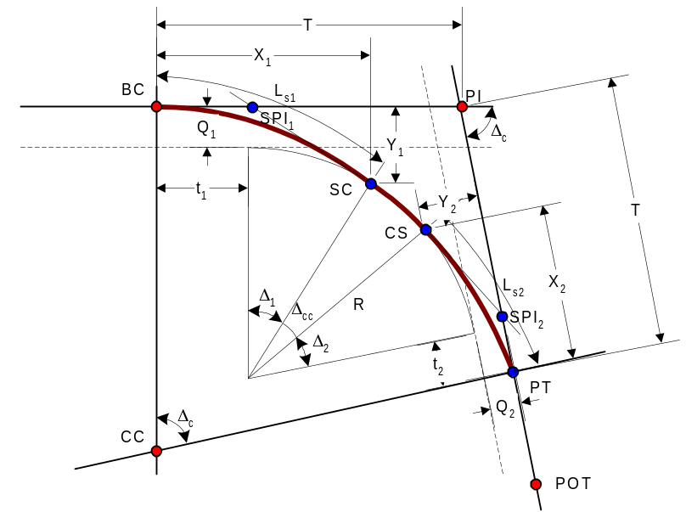
Figure 1 Horizontal Curve with Entry and Exit Spirals
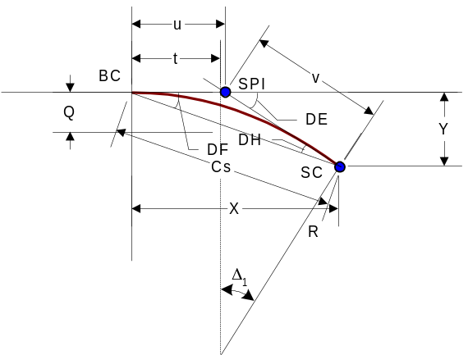
Figure 2 Spiral Details
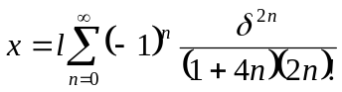
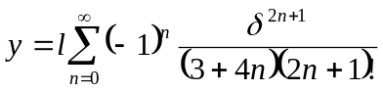
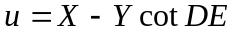
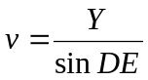
Equation 1 Spiral Curve Equations
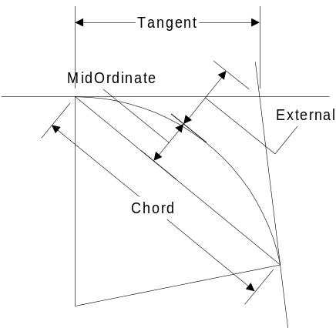
Figure 3 Circular Curve Properties
Properties
 | BC | Set/Get the point of curvature
 | PI | Set/Get the intersection point
 | POT | Set/Get a point on the forward tangent
 | CC | Set/Get the center of the curve
 | EntrySpiralLength | Set/Get the length of the entry spiral (L_{s1})
 | ExitSpiralLength | Set/Get the length of the exit spiral (L_{s2})
 | EntrySpiralAngle | Set/Get the angle of the entry spiral (Δ₁)
 | ExitSpiralAngle | Set/Get the angle of the exit spiral (Δ₂)
 | TotalLength | Returns the total length of the entire curve
 | Length | Returns the length of the circular curve
 | TotalTangent | Returns the tangent distance for the entire curve
 | Tangent | Returns the tangent distance for the circular curve
 | MidOrdinate | Returns the mid ordinate for the circular curve
 | External | Returns the external for the circular curve
 | Chord | Returns the chord distance for the circular curve
 | Radius | Returns the radius for the circular curve
 | FwdTangentBrg | Returns the bearing of the forward tangent
 | BkTangentBrg | Returns the bearing of the back tangent
Methods
Events

Properties

BC
Summary: | Set/Get the point of curvature
Syntax: | intID = object.BC  object.BC = intID
Syntax: | Element | Description
Syntax: | intID | ID of a point
Syntax: | object | This HorzCurve object
Remarks:
Also See:

PI
Summary: | Set/Get the point of intersection
Syntax: | intID = object.PI  object.PI = intID
Syntax: | Element | Description
Syntax: | intID | ID of a point
Syntax: | object | This HorzCurve object
Remarks:
Also See:

POT
Summary: | Set/Get a point on the forward tangent
Syntax: | intID = object.POT  object.POT = intID
Syntax: | Element | Description
Syntax: | intID | ID of a point
Syntax: | object | This HorzCurve object
Remarks:
Also See:

CC
Summary: | Set/Get the center of the curve
Syntax: | intID = object.CC  object.CC = intID
Syntax: | Element | Description
Syntax: | intID | ID of a point
Syntax: | object | This HorzCurve object
Remarks:
Also See:

EntrySpiralLength
Summary: | Set/Get the length of the entry spiral
Syntax: | dblLen = object.EntrySpiralLength  object.EntrySpiralLength = dblLen
Syntax: | Element | Description
Syntax: | dblLen | Length of the entry spiral
Syntax: | object | This HorzCurve object
Remarks:
Also See:

ExitSpiralLength
Summary: | Set/Get the length of the exit spiral
Syntax: | dblLen = object.ExitSpiralLength  object.ExitSpiralLength = dblLen
Syntax: | Element | Description
Syntax: | dblLen | Length of the exit spiral
Syntax: | object | This HorzCurve object
Remarks:
Also See:

TotalLength
Summary: | Returns the total length of the entire curve
Syntax: | dblLen = object.TotalLength
Syntax: | Element | Description
Syntax: | dblLen | The total length of the curve
Syntax: | object | This HorzCurve object
Remarks: | The total length of the curve is sum of the entry spiral length, the circular curve length, and the exit spiral length
Also See:

Length
Summary: | Returns the length of the circular curve
Syntax: | dblLen = object.Length
Syntax: | Element | Description
Syntax: | dblLen | The length of the curve
Syntax: | object | This HorzCurve object
Remarks:
Also See:

TotalTangent
Summary: | Returns the tangent distance for the entire curve
Syntax: | dblTan = object.TotalTangent
Syntax: | Element | Description
Syntax: | dblTan | The tangent distance
Syntax: | object | This HorzCurve object
Remarks:
Also See:

Tangent
Summary: | Returns the tangent distance for the circular curve
Syntax: | dblTan = object.Tangent
Syntax: | Element | Description
Syntax: | dblTan | The tangent distance
Syntax: | object | This HorzCurve object
Remarks:
Also See:

MidOrdinate
Summary: | Returns the mid ordinate for the circular curve
Syntax: | dblMO = object.MidOrdinate
Syntax: | Element | Description
Syntax: | dblMO | Mid ordinate of the circular curve
Syntax: | object | This HorzCurve object
Remarks:
Also See:

External
Summary: | Returns the external for the circular curve
Syntax: | dblExt = object.External
Syntax: | Element | Description
Syntax: | dblExt | The external distance
Syntax: | object | This HorzCurve object
Remarks:
Also See:

Chord
Summary: | Returns the chord distance for the circular curve
Syntax: | dblCh = object.Chord
Syntax: | Element | Description
Syntax: | dblCh | The chord distance
Syntax: | object | This HorzCurve object
Remarks:
Also See:

Radius
Summary: | Returns the radius for the circular curve
Syntax: | dblR = object.Radius
Syntax: | Element | Description
Syntax: | dblR | The radius
Syntax: | object | This HorzCurve object
Remarks:
Also See:

FwdTangentBrg
Summary: | Returns the bearing of the forward tangent
Syntax: | objBrg = object.FwdTangentBrg
Syntax: | Element | Description
Syntax: | objBrg | A Direction object
Syntax: | object | This HorzCurve object
Remarks:
Also See:

BkTangentBrg
Summary: | Returns the bearing of the back tangent
Syntax: | objBrg = object.BkTangentBrg
Syntax: | Element | Description
Syntax: | objBrg | A Direction object
Syntax: | object | This HorzCurve object
Remarks:
Also See:

Methods

Method1
Summary:
Syntax:
Syntax: | Element | Description
Remarks:
Also See:

Events

Event1
Summary:
Syntax:
Syntax: | Element | Description
Remarks:
Also See:

IProfilePoint
Interface implemented by ProfilePoint objects. A ProfilePoint is a point in a vertical profile. A profile point is defined by its station and elevation
Properties
 | Station | Get/Sets the station
 | Elevation | Get/Sets the elevation
Methods
Events

Properties

Station
Summary: | Get/Sets the station
Syntax: | dblSta = object.Station  object.Station = dblSta
Syntax: | Element | Description
Syntax: | dblSta | The station
Syntax: | object | This ProfilePoint object
Remarks:
Also See:

Elevation
Summary: | Get/Sets the elevation
Syntax: | dblElev = object.Elevation  object.Elevation = dblElev
Syntax: | Element | Description
Syntax: | dblElev | Profile grade elevation
Syntax: | object | This ProfilePoint object
Remarks:
Also See:

Methods

Method1
Summary:
Syntax:
Syntax: | Element | Description
Remarks:
Also See:

Events

Event1
Summary:
Syntax:
Syntax: | Element | Description
Remarks:
Also See:

IVertCurve
Interface implemented by VertCurve objects. A VertCurve object represents a vertical curve in a profile. Vertical curves may be sag or crest curves, and may be simple or compound.
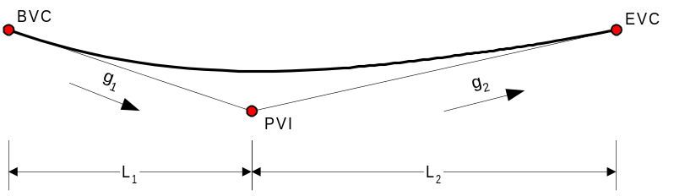
Figure 4 Vertical Curve
Properties
 | BVC | Get/Sets the beginning vertical curve profile point
 | PVI | Get/Sets the point of vertical intersection point
 | EVC | Get/Sets the end vertical curve profile point
 | Length | Returns the horizontal length of the vertical curve
 | EntryGrade | Returns the entry grade
 | ExitGrade | Returns the exit grade
 | LowPoint | Returns a profile point for the lowest point on the curve
 | HighPoint | Returns a profile point for the highest point on the curve
Methods
 | Elevation | Computes the elevation at a given station
Events

Properties

BVC
Summary: | Get/Sets the beginning vertical curve profile point
Syntax: | intBVC = object.BVC  object.BVC = intBVC
Syntax: | Element | Description
Syntax: | intBVC | ID of the beginning of vertical curve profile point
Syntax: | object | This VertCurve object
Remarks:
Also See:

PVI
Summary: | Get/Sets the point of vertical intersection point
Syntax: | intPVI = object.PVI  object.PVI = intPVI
Syntax: | Element | Description
Syntax: | intPVI | ID of the point of vertical intersection profile point
Syntax: | object | This VertCurve object
Remarks:
Also See:

EVC
Summary: | Get/Sets the ending vertical curve profile point
Syntax: | intEVC = object.EVC  object.EVC = intEVC
Syntax: | Element | Description
Syntax: | intEVC | ID of the ending of vertical curve profile point
Syntax: | object | This VertCurve object
Remarks:
Also See:

Length
Summary: | Returns the horizontal length of the vertical curve
Syntax: | dblLength = object.Length
Syntax: | Element | Description
Syntax: | dblLength | length of the vertical curve
Syntax: | object | This VertCurve object
Remarks:
Also See:

EntryGrade
Summary: | Returns the entry grade
Syntax: | dblG1 = object.EntryGrade
Syntax: | Element | Description
Syntax: | dblG1 | The entry grade
Syntax: | object | This VertCurve object
Remarks:
Also See:

ExitGrade
Summary: | Returns the exit grade
Syntax: | dblG2 = object.ExitGrade
Syntax: | Element | Description
Syntax: | dblG2 | The exit grade
Syntax: | object | This VertCurve object
Remarks:
Also See:

LowPoint
Summary: | Returns a profile point for the lowest point on the curve
Syntax: | objPnt = object.LowPoint
Syntax: | Element | Description
Syntax: | objPnt | A ProfilePoint object representing the lowest pointing the curve
Syntax: | object | This VertCurve object
Remarks:
Also See:

HighPoint
Summary: | Returns a profile point for the highest point on the curve
Syntax: | objPnt = object.LowPoint
Syntax: | Element | Description
Syntax: | objPnt | A ProfilePoint object representing the highest pointing the curve
Syntax: | object | This VertCurve object
Remarks:
Also See:

Methods

Elevation
Summary: | Computes the elevation at a given station
Syntax: | dblElev = object.Elevation(dblSta)
Syntax: | Element | Description
Syntax: | dblElev | A profile grade elevation
Syntax: | object | This VertCurve object
Syntax: | dblSta | The station where the elevation is to be computed
Remarks:
Also See:

Events

Event1
Summary:
Syntax:
Syntax: | Element | Description
Remarks:
Also See:

IAlignment
Interface implemented by Alignment objects. This interface is used to describe a horizontal alignment. An alignment consists of alignment elements, which are: points, line segments, and horizontal curves. Alignment elements are positioned end to end in the order they are defined. The tangents at the beginning and end of the alignment are projected for stations not explicitly defined.

If an Alignment does not contain any AlignmentElement items, it is assumed that Station 0+00 is located at N 0.00, E 0.00, and the alignment is a straight bearing a N 90 E.
Properties
 | RefStation | Get/Set the reference station
 | Item | Get/Sets an alignment element
 | Profile | Get/Set the associated profile
 | Length | Returns the length of the alignment
Methods
 | AddElement | Adds an alignment element
 | InsertElement | Inserts an alignment element
 | RemoveElement | Removes an alignment element
 | FindElement | Returns the alignment element at the specified station
 | LocatePoint | Locates a point relative to the alignment
 | ProjectPoint | Projects a point onto the alignment
 | Bearing | Returns the bearing of the alignment at a given station
 | Normal | Returns the bearing of a line normal to the alignment at a given station
 | StationOffset | Computes the station and normal offset for a given point
Events

Properties

RefStation
Summary: | Get/Set the reference station
Syntax: | dblSta = object.RefStation  object.RefStation = dblSta
Syntax: | Element | Description
Syntax: | dblSta | The reference station for the alignment
Syntax: | object | This Alignment object
Remarks: | The reference station is the stationing value assigned to the beginning point of the first alignment element. All other stations are computed relative to this station.
Also See:

Item
Summary: | Get/Sets an alignment element
Syntax: | objAlignEle = object.Item(index)  object.Item(index) = objAlignEle
Syntax: | Element | Description
Syntax: | objAlignEle | An AlignmentElement object
Syntax: | object | This Alignment object
Syntax: | index | Zero-based index of the alignment element
Remarks:
Also See:

Profile
Summary: | Get/Set the associated profile
Syntax: | objProfile = object.Profile  object.Profile = objProfile
Syntax: | Element | Description
Syntax: | objProfile | A Profile object
Syntax: | object | This Alignment object
Remarks:
Also See:

Methods

AddElement
Summary: | Adds an alignment element
Syntax: | object.AddElement(objAlignEle)
Syntax: | Element | Description
Syntax: | object | This Alignment object
Syntax: | objAlignEle | An AlignmentElement object
Remarks:
Also See:

InsertElement
Summary: | Inserts an alignment element
Syntax: | object.InsertElement(index,objAlignEle)
Syntax: | Element | Description
Syntax: | object | This Alignment object
Syntax: | index | The zero-based index at which to insert the alignment element
Syntax: | objAlignEle | An AlignmentElement object
Remarks:
Also See:

RemoveElement
Summary: | Removes an alignment element
Syntax: | object.RemoveElement(varKey)
Syntax: | Element | Description
Syntax: | object | This Alignment object
Syntax: | varKey | Variant key used to specify which alignment element to remove
Remarks: | varKey can be a zero-based index or an AlignmentElement object.  Recall that profile elements are sorted based on station. A profile element may not be at the same index in the container as when you added it.
Also See:

FindElement
Summary: | Returns the alignment element at the specified station
Syntax: | objAlignEle = object.FindElement(dblSta)
Syntax: | Element | Description
Syntax: | objAlignEle | The AlignmentElement object that was found
Syntax: | object | This Alignment element
Syntax: | dblSta | Station at which an alignment element is desired
Remarks: | Returns Nothing if station is not contained within the alignment
Also See:

LocatePoint
Summary: | Locates a point relative to the alignment
Syntax: | object.LocatePoint(newID,dblSta[,dblOffset[,varDir]])
Syntax: | Element | Description
Syntax: | object | This Alignment object
Syntax: | newID | ID of the newly created point
Syntax: | dblSta | Station used to locate the point
Syntax: | dblOffset | Offset from the alignment to the point.
Syntax: | varDir | Direction of line on which the point is located
Remarks: | 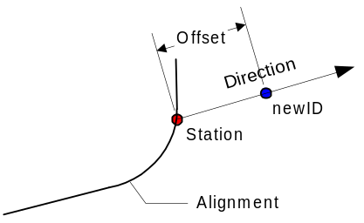  dblOffset and varDir are optional parameters. If they are omitted, the point is located directly on the alignment.  varDir can be either a Direction object or an azimuth in radians.  dblOffset locates the point offset from the alignment. Positive values offset the point to the right of the alignment, looking ahead on station. The offset is measured in the direction defined by varDir. If varDir is omitted, the offset is measured normal to the alignment.
Also See:

ProjectPoint
Summary: | Projects a point onto the alignment
Syntax: | object.ProjectPoint(newID,fromID)
Syntax: | Element | Description
Syntax: | object | This Alignment object
Syntax: | newID | ID of the new point
Syntax: | fromID | ID of the point to be projected
Remarks: | 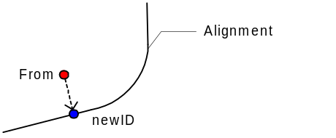
Also See:

Bearing
Summary: | Returns the bearing of the alignment at a given station
Syntax: | objBrg = object.Bearing(dblSta)
Syntax: | Element | Description
Syntax: | objBrg | A Direction object representing the bearing
Syntax: | object | This Alignment object
Syntax: | dblSta | The station where the bearing is computed
Remarks: | 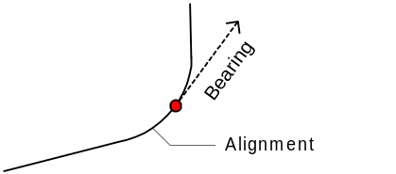  The bearing is in the direction of increasing station
Also See:

Normal
Summary: | Returns the bearing of a line normal to the alignment at a given station
Syntax: | objNorm = object.Normal(dblSta)
Syntax: | Element | Description
Syntax: | objNorm | A Direction object representing the normal bearing
Syntax: | object | This Alignment object
Syntax: | dblSta | The station where the normal is computed
Remarks: | 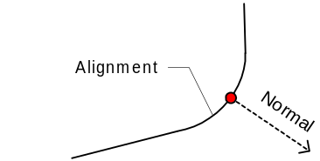  The normal direction is towards the right of the alignment, viewed ahead on station
Also See:

StationOffset
Summary: | Computes the station and normal offset for a given point
Syntax: | object.StationOffset(ID,[out]dblSta,[out]dblOffset)
Syntax: | Element | Description
Syntax: | object | This Alignment object
Syntax: | ID | ID of the point to compute the station and offset for
Syntax: | dblSta | The station
Syntax: | dblOffset | The offset
Remarks: | 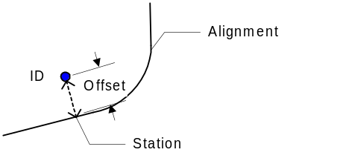  Negative offsets are to the left of the alignment, viewed ahead on station.
Also See:

Events

Event1
Summary:
Syntax:
Syntax: | Element | Description
Remarks:
Also See:

IAlignmentElement
Interface implemented by AlignmentElement objects. An AlignmentElement object represents an element (point, line segment, curve) in a horizontal alignment.
Properties
 | Type | Set/Get the alignment element type
 | ID | Set/Get the identifier of the alignment element
Methods
Events

Properties

Type
Summary: | Set/Get the alignment element type
Syntax: | aeType = object.Type  object.Type = aeType
Syntax: | Element | Description
Syntax: | aeType | A constant defining the alignment element type
Syntax: | object | This AlignmentElement object
Remarks:
Also See:

ID
Summary: | Set/Get the identifier of the alignment element
Syntax: | id = object.ID  object.ID = id
Syntax: | Element | Description
Syntax: | id | Identifier of a previously stored point, line segment, or curve
Syntax: | object | This AlignmentElement object
Remarks:
Also See:

Methods

Method1
Summary:
Syntax:
Syntax: | Element | Description
Remarks:
Also See:

Events

Event1
Summary:
Syntax:
Syntax: | Element | Description
Remarks:
Also See:

IProfile
Interface implemented by Profile objects. A profile object represents the vertical profile along an alignment. A profile can consist of profile points and vertical curves. These “ProfileElements” are sorted within the container by their stationing. Errors may occur if more that one profile element is defined at a station.

If the profile does not contain any ProfileElements, the profile will be assumed flat, at an elevation of 0.00.

If the profile contains exactly one ProfileElement, and the profile element is a ProfilePoint, the profile is assumed flat, at the elevation of the profile point.
Properties
 | Item | Get/Sets a profile element
 | Count | Returns the number of items in the collection
 | CrossSections | Get/Set the associated cross sections
Methods
 | AddElement | Adds a profile element
 | RemoveElement | Removes a profile element
 | FindElement | Returns the profile element at the specified station
 | Elevation | Computes the elevation at the specified station and offset.
 | Grade | Computes the profile grade at the specified station.
Events

Properties

Item
Summary: | Get/Sets a profile element
Syntax: | objProfEle = object.Item(index)
Syntax: | Element | Description
Syntax: | objProfEle | A ProfileElement object
Syntax: | object | This Profile object
Syntax: | index | Zero-based index of the profile element
Remarks:
Also See:

Count
Summary: | Returns the number of items in the collection
Syntax: | lCount = object.Count
Syntax: | Element | Description
Syntax: | lCount | The number of ProfileElement objects in the profile
Syntax: | object | This Profile object
Remarks:
Also See:

CrossSections
Summary: | Get/Set the associated cross sections
Syntax: | objCS = object.CrossSections  object.CrossSections = objCS
Syntax: | Element | Description
Syntax: | objCS | A CrossSections collection object
Syntax: | object | This Profile object
Remarks:
Also See:

Length
Summary: | Returns the length of the alignment
Syntax: | dblLen = object.Length
Syntax: | Element | Description
Syntax: | dblLen | The length of the alignment
Syntax: | object | This Alignment object
Remarks: | Length is computed as the cumulative length of all the alignment elements and the distance between the alignment elements.
Also See:

Methods

AddElement
Summary: | Adds a profile element
Syntax: | object.AddElement(objProfEle)
Syntax: | Element | Description
Syntax: | object | This Profile object
Syntax: | objProfEle | The ProfileElement to be added
Remarks:
Also See:

RemoveElement
Summary: | Removes a profile element
Syntax: | object.RemoveElement(varKey)
Syntax: | Element | Description
Syntax: | object | This Profile object
Syntax: | varKey | Variant key used to specify which profile element to remove
Remarks: | varKey can be a zero-based index, station, or ProfileElement object.  Recall that profile elements are sorted based on station. A profile element may not be at the same index in the container as when you added it.
Also See:

FindElement
Summary: | Returns the profile element at the specified station
Syntax: | objProfEle = object.FindElement(dblSta)
Syntax: | Element | Description
Syntax: | objProfEle | A ProfileElement object
Syntax: | object | This Profile object
Syntax: | dblSta | Station where the profile element is desired
Remarks: | Returns Nothing if station is not contained within the profile
Also See:

Elevation
Summary: | Computes the elevation at the specified station and offset.
Syntax: | dblElev = object.Elevation(dblSta,dblOffset)
Syntax: | Element | Description
Syntax: | dblElev | The elevation
Syntax: | object | This Profile object
Syntax: | dblSta | The station where the elevation is to be computed
Syntax: | dblOffset | The offset from the profile where the elevation is to be computed.
Remarks: | The offset is normal to the alignment. Positive values for offset represent points to the right of the alignment when viewed ahead on station.
Also See:

Grade
Summary: | Computes the profile grade at the specified station.
Syntax: | dblGrade = object.Grade(dblSta)
Syntax: | Element | Description
Syntax: | dblGrade | The profile grade
Syntax: | object | This Profile object
Syntax: | dblSta | The station where the profile grade is to be computed
Remarks: | Positive grades are uphill, in the direction of increasing station.
Also See:

Events

Event1
Summary:
Syntax:
Syntax: | Element | Description
Remarks:
Also See:

IProfileElement
Interface implemented by ProfileElement objects. A ProfileElement object represents an element (profile point, vertical curve) in a vertical profile.
Properties
 | Type | Set/Get the profile element type
 | ID | Set/Get the identifier of the profile element
Methods
Events

Properties

Type
Summary: | Set/Get the profile element type
Syntax: | peType = object.Type  object.Type = peType
Syntax: | Element | Description
Syntax: | peType | A constant defining the profile element type
Syntax: | object | This ProfileElement object
Remarks:
Also See:

ID
Summary: | Set/Get the identifier of the profile element
Syntax: | id = object.ID  object.ID = id
Syntax: | Element | Description
Syntax: | id | Identifier of a previously stored elevation point or vertical curve
Syntax: | object | This ProfileElement object
Remarks:
Also See:

Methods

Method1
Summary:
Syntax:
Syntax: | Element | Description
Remarks:
Also See:

Events

Event1
Summary:
Syntax:
Syntax: | Element | Description
Remarks:
Also See:

ICrossSections
Interface implemented by the CrossSections collection. The CrossSections collection is a container of CrossSection objects. CrossSection objects define cross section of the roadway surface. Cross sections are defined normal to the alignment. Cross slopes are linearly interpolated between cross sections.
Properties
 | Item | Returns an item from the collection
 | Count | Returns the number of items in the collection
Methods
 | Add | Adds a CrossSection object to the collection
 | Remove | Removes a CrossSection object from the collection
 | CreateCrossSection | Creates a cross section object that represents the cross section at a given station.
 | CrossSlope | Returns the cross slope at a given station
Events

Properties

Item
Summary: | Returns an item from the collection
Syntax: | objCS = object.Item(index)
Syntax: | Element | Description
Syntax: | objCS | A CrossSection object
Syntax: | object | This CrossSections collection
Syntax: | index | Zero-based index
Remarks:
Also See:

Count
Summary: | Returns the number of items in the collection
Syntax: | lCount = object.Count
Syntax: | Element | Description
Syntax: | lCount | The number of items in the collection
Syntax: | object | This CrossSections collection
Remarks:
Also See:

Methods

Add
Summary: | Adds a CrossSection object to the collection
Syntax: | object.Add(objCS)
Syntax: | Element | Description
Syntax: | object | This CrossSections collection
Syntax: | objCS | The CrossSection object to be added
Remarks: | Cross section objects are sorted based on station
Also See:

Remove
Summary: | Removes a CrossSection object from the collection
Syntax: | object.Remove(varKey)
Syntax: | Element | Description
Syntax: | object | This CrossSections collection
Syntax: | varKey | A key to identify which cross section object to remove
Remarks: | varKey can be a zero-based index, station, or CrossSection object.  Recall that cross sections are sorted based on station. A cross section may not be at the same index in the container as when you added it.
Also See:

CreateCrossSection
Summary: | Creates a cross section object that represents the cross section at a given station.
Syntax: | objCS = object.CreateCrossSection(dblSta)
Syntax: | Element | Description
Syntax: | objCS | The newly created CrossSection object
Syntax: | object | This CrossSections collection
Syntax: | dblSta | The station where the cross section object is to be created
Remarks: | This method creates a CrossSection object based on the other cross sections currently defined in the collection. The newly created cross section object is not added to the collection.
Also See:

CrossSlope
Summary: | Computes the cross slope at the specified station and offset
Syntax: | dblSlope = object.CrossSlope(dblSta,dblOffset)
Syntax: | Element | Description
Syntax: | dblSlope | The cross slope
Syntax: | object | This Profile object
Syntax: | dblSta | The station where the cross slope is to be computed
Syntax: | dblOffset | The offset where the cross slope is to be computed
Remarks: | Positive slopes are downwards from the crown point when looking ahead on station.
Also See:

Events

Event1
Summary:
Syntax:
Syntax: | Element | Description
Remarks:
Also See:

ICrossSection
Interface implemented by CrossSection objects. A cross section object represents the cross section of the roadway surface. Slopes are always measured when looking up station.
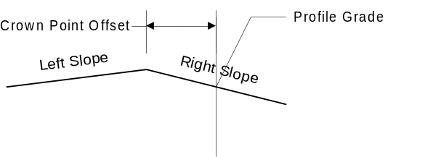
Figure 5 Cross Section Diagram Looking Up Station (offset shown is negative)
Properties
 | Station | Get/Sets the station where this cross section occurs
 | CrownPointOffset | Get/Sets the crown point offset
 | LeftSlope | Get/Sets the slope to the left of the crown point
 | RightSlope | Get/Sets the slope to the right of the crown point
Methods
Events

Properties

Station
Summary: | Get/Sets the station where this cross section occurs
Syntax: | dblSta = object.Station  object.Station = dblSta
Syntax: | Element | Description
Syntax: | dblSta | The station
Syntax: | object | This CrossSection object
Remarks:
Also See:

CrownPointOffset
Summary: | Get/Sets the crown point offset
Syntax: | dblCPO = object.CrownPointOffset  object.CrownPointOffset = dblCPO
Syntax: | Element | Description
Syntax: | dblCPO | The crown point offset
Syntax: | object | This CrossSection object
Remarks: | Positive offsets position the crown point to the right of the profile grade line
Also See:

LeftSlope
Summary: | Get/Sets the slope to the left of the crown point
Syntax: | dblSlope = object.LeftSlope  object.LeftSlope = dblSlope
Syntax: | Element | Description
Syntax: | dblSlope | The cross slope on the left side of the crown point
Syntax: | object | This CrossSection object
Remarks: | Positive slopes are down and towards the left. Negative slopes are up and towards the left.
Also See:

RightSlope
Summary: | Get/Sets the slope to the right of the crown point
Syntax: | dblSlope = object.RightSlope  object.RightSlope = dblSlope
Syntax: | Element | Description
Syntax: | dblSlope | The cross slope on the right side of the crown point
Syntax: | object | This CrossSection object
Remarks: | Positive slopes are down and towards the right. Negative slopes are up and towards the right.
Also See:

Methods

Method1
Summary:
Syntax:
Syntax: | Element | Description
Remarks:
Also See:

Events

Event1
Summary:
Syntax:
Syntax: | Element | Description
Remarks:
Also See:

IAngleDisplayUnitFormatter
Interface implemented by AngleDisplayUnitFormatter. This interface extends WBFLUnitServer::IDisplayUnitFormatter.

If UnitTag is true, add deg, min, sec symbols. Options for displaying as (+/-) number or L/R angle, in decimal or DMS format. DMS can be full or condensed.
Properties
Methods
Events

Properties

Prop1
Summary:
Syntax:
Syntax: | Element | Description
Remarks:
Also See:

Methods

Method1
Summary:
Syntax:
Syntax: | Element | Description
Remarks:
Also See:

Events

Event1
Summary:
Syntax:
Syntax: | Element | Description
Remarks:
Also See:

IDirectionDisplayUnitFormatter
Interface implemented by DirectionDisplayUnitFormatter. This interface extends WBFLUnitServer::IDisplayUnitFormatter.

If uses tag is true, add deg, min, sec symbols. Option for displaying full (N 45 00 00.0 E) or condensed (N 45 E). Option for displaying as Azimuth
Properties
Methods
Events

Properties

Prop1
Summary:
Syntax:
Syntax: | Element | Description
Remarks:
Also See:

Methods

Method1
Summary:
Syntax:
Syntax: | Element | Description
Remarks:
Also See:

Events

Event1
Summary:
Syntax:
Syntax: | Element | Description
Remarks:
Also See:

<Interface Name>
<Description>
Properties
Methods
Events

Properties

Prop1
Summary:
Syntax:
Syntax: | Element | Description
Remarks:
Also See:

Methods

Method1
Summary:
Syntax:
Syntax: | Element | Description
Remarks:
Also See:

Events

Event1
Summary:
Syntax:
Syntax: | Element | Description
Remarks:
Also See:

Constants

AlignmentElementType
Constant describing an alignment element
Constant | Value | Description
aePoint | 1 | Alignment element is a point
aeLineSegment | 2 | Alignment element is a line segment
aeCurve | 3 | Alignment element is a horizontal curve

ProfileElementType
Constant describing a profile element
Constant | Value | Description
pePoint | 1 | Profile element is a profile point
peVertCurve | 2 | Profile element is a vertical curve

NSDirectionType
Constant describing the general north/south direction of a bearing
Constant | Value | Description
nsNorth | 1 | Bearing is in a northerly direction
nsSout | 2 | Bearing is in a southerly direction

EWDirectionType
Constant describing the general east/west direction of a bearing
Constant | Value | Description
ewEast | 1 | Bearing is in an easterly direction
ewWest | 2 | Bearing is in a westerly direction

<Constant Name>
<Description>
Constant | Value | Description

